**Welcome Page -- Health Disparities, General and Sexual Orientation Minorities**

**Home About Contact eReport**

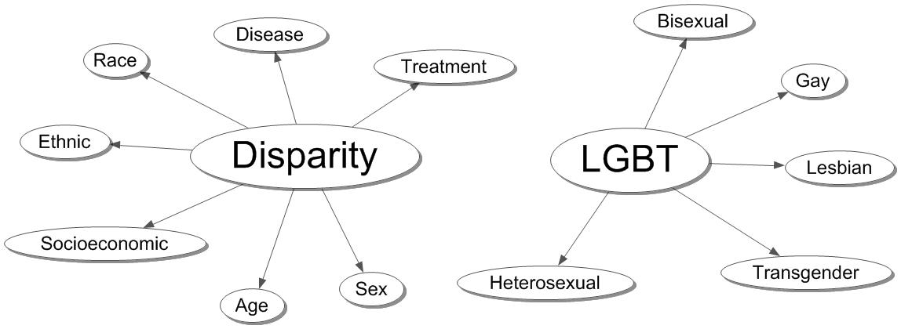

***Click on the Dimension to Retrieve Ideas describing that topic. These reduced sets focus on specific issues.***

**Total Ideas By Time and Content**

***Alternatively, Retrieve Ideas Dealing with Any Term in the Vocabulary. These files are divided into segments to facilitate rapid downloading.***

|  |  |  |
| --- | --- | --- |
| **Time Period** | **Content** | **Description** |
| **1990 - 2015** | **Idea Term Vocabulary** | **Frequency Each Idea** |
| **1990 - 1999** | **Aboriginal - Workplace** | **Ideas Involving Each Primary Term** |
| **2000 - 2004** | **Access - Vision** | **Ideas Involving Each Primary Term** |
| **2005 - 2009** | **Aboriginal - Caribbean** | **Ideas Involving Each Primary Term** |
| **2005 - 2009** | **Caries - Environment** | **Ideas Involving Each Primary Term** |
| **2005 - 2009** | **Epidemic - Health** | **Ideas Involving Each Primary Term** |
| **2005 - 2009** | **Hearing - Poor** | **Ideas Involving Each Primary Term** |
| **2005 - 2009** | **Population - Workplace** | **Ideas Involving Each Primary Term** |
| **2010 - 2011** | **Aboriginal - Disparities** | **Ideas Involving Each Primary Term** |
| **2010 - 2011** | **Disparity - Ovarian** | **Ideas Involving Each Primary Term** |
| **2010 - 2011** | **Overweight - Workplace** | **Ideas Involving Each Primary Term** |
| **2012 - 2013** | **Aboriginal - Cataract** | **Ideas Involving Each Primary Term** |
| **2012 - 2013** | **Caucasian - Etiology** | **Ideas Involving Each Primary Term** |
| **2012 - 2013** | **Europe - Korean** | **Ideas Involving Each Primary Term** |
| **2012 - 2013** | **Latino - Race** | **Ideas Involving Each Primary Term** |
| **2012 - 2013** | **Racial - Workplace** | **Ideas Involving Each Primary Term** |
| **2014 - 2015 (July)** | **Aboriginal - Cerebrovascular** | **Ideas Involving Each Primary Term** |
| **2014 - 2015 (July)** | **Cervical - Geographic** | **Ideas Involving Each Primary Term** |
| **2014 - 2015 (July)** | **German - Myocardial** | **Ideas Involving Each Primary Term** |
| **2014 - 2015 (July)** | **National - Workplace** | **Ideas Involving Each Primary Term** |

Trailer

***Center for the Study of Scientific Ideas Web Design***

***XXIV Century Press Andrew Keller***

***Copyright 2015***

***Contact –*** [***learning@tutorghost.com***](mailto:learning@tutorghost.com)